TITLE OF ARTICLE

Presenting Author¹, Another Author ², Another Author ²

¹ Sample University, Test City, AZ, USA
² Sample Research Institute, München, Germany

This is a short summary of the research. Its length should not exceed 2000 characters. Please do not insert any figure or table to this part of the article. A paper can be 4 pages long, including the header, abstract, paper text, tables, figures and references.
Lorem ipsum dolor sit amet, consectetur adipiscing elit. Quisque neque lacus, mollis vitae feugiat vel, laoreet ac ante. Vivamus vehicula aliquam nibh in sodales. Etiam ac nulla a orci vehicula egestas. Aliquam vulputate lobortis est, eu ultrices lectus laoreet vel. Nulla viverra dapibus facilisis. Proin lobortis elit a urna eleifend dapibus. Pellentesque et ipsum quis justo feugiat sodales sit amet ut eros. Quisque suscipit fermentum lorem. Proin porta tortor ut metus tempus malesuada.
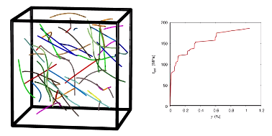
Figure 1: Sample figure
Aliquam erat volutpat. Phasellus consectetur convallis sem a tempus. Morbi ut nisl a neque pretium consequat in et dui. Aliquam erat volutpat. Donec vehicula lacinia mi. Aenean mattis nibh in purus sollicitudin tristique. Cras ultricies facilisis ligula sed commodo. In hac habitasse platea dictumst. Proin aliquet venenatis diam non fringilla. Praesent sit amet ipsum ante, vehicula aliquam tortor.
Test header | Column 1 | Column 2
Row 1 | Value 1 | Value 2
Table 1: Sample table
References:
[1] Joseph Anonymous: Lorem Ipsum Generator, 2012, http://en.lipsum.com/

